# Supplemental Tables & Figures

| **Supplemental Table 1.** Standard Protocol Items: Recommendations for Interventional Trials (SPIRIT) Checklist | | | | | | | | | | | | |
| --- | --- | --- | --- | --- | --- | --- | --- | --- | --- | --- | --- | --- |
|  | **STUDY PERIOD** | | | | | | | | | | | |
|  | **Enrollment** | **Allocation** | **Post-allocation** | | | | | | | |  | **Close-out** |
| **TIMEPOINT** | **Day 0** | **Day 1** | **Day 5** | | **Day 26** | **Day 35** | **Day 54** | **Day 75** | **Day 90** | **Day 103** | | **Day 110** |
| **ENROLLMENT:** |  |  |  | |  |  |  |  |  |  | |  |
| **Eligibility screen** | **X** |  |  | |  |  |  |  |  |  | |  |
| **Informed consent** | **X** |  |  | |  |  |  |  |  |  | |  |
| **Allocation** |  | **X** |  | |  |  |  |  |  |  | |  |
| **INTERVENTIONS:** |  |  |  | |  |  |  |  |  |  | |  |
| **Lecture section** |  |  |  |  |  |  |  |  |  |  |  |  |
|  |  |  |  |  |  |  |
|  |  |  |  |  |  |  |
|  |  |  |  |  |  |  |
| **Flipped section** |  |  |  |  |  |  |  |  |  |  |  |  |
|  |  |  |  |  |  |  |
|  |  |  |  |  |  |  |
|  |  |  |  |  |  |  |
| **ASSESSMENTS:** |  |  |  | |  |  |  |  |  |  | |  |
| **GPA calculations** | **X** |  |  | |  |  |  |  |  |  | |  |
| **Neurobiology pre-test** |  | **X** |  | |  |  |  |  |  |  | |  |
| **Quiz** |  |  |  |  |  |  |  |  |  |  |  |  |
|  |  |  |  |  |  |  |
|  |  |  |  |  |  |  |
|  |  |  |  |  |  |  |
| **Post-test** |  |  |  |  |  |  |  |  |  |  |  |  |
|  |  |  |  |  |  |  |
|  |  |  |  |  |  |  |
|  |  |  |  |  |  |  |
| **Exam** |  |  |  | | **X** |  | **X** | **X** |  | **X** | |  |
| **Final exam** |  |  |  | |  |  |  |  |  |  | | **X** |
| **Satisfaction survey** |  |  |  | |  | **X** |  |  | **X** |  | |  |

| **Supplemental Table 2.** Multiple Linear Regression Analysis of Exam Scores | | | |
| --- | --- | --- | --- |
| **Variable** | **Coefficient** | **95% Confidence Interval** | **P-value** |
| Age (months) | -0.96 | -1.95 to 0.04 | 0.0598 |
| Sex (male) | 0.46 | -2.43 to 3.34 | 0.753 |
| Neurobiology pre-test (%) | 0.1 | -0.06 to 0.26 | 0.2224 |
| Undergraduate cumulative GPA | 0.31 | -6.91 to 7.52 | 0.933 |
| Undergraduate science GPA | -8.25 | -23.63 to 7.13 | 0.2887 |
| Graduate GPA | 16.67 | 9.16 to 24.18 | <0.0001 |
| Review type (reviewed) | 10.85 | 7.7 to 13.99 | <0.0001 |
| Class section (lecture) | -1.54 | -4.73 to 1.66 | 0.341 |
| Review type (reviewed) : class section (lecture) | 1.15 | -3.3 to 5.6 | 0.6083 |
| Adjusted r² = 0.64.  The following formula below was used to generate the linear model.  exam score ~ age + sex + neurobiology pre-test + sGPA + cGPA + gGPA + review type * class section | | | |

| **Supplemental Table 3.** Student Satisfaction Survey Results | | | | |
| --- | --- | --- | --- | --- |
| **Item** | **Timepoint** | **Lecture section (n = 21)** | **Flipped section (n = 21)** | **Lecture vs. flipped** |
| Total (all items) | 5 weeks | 32.65 ± 6.15 | 36.05 ± 3.63 | p = 0.16 |
| 15 weeks | 31.76 ± 6.93 | 38.95 ± 2.78 | p < 0.0001 |
| 5 vs 15 weeks | p = 1 | p = 0.02 |  |
| The teaching methods used in class are helpful and effective. | 5 weeks | 3.9 ± 0.79 | 4.35 ± 0.59 | p = 0.25 |
| 15 weeks | 3.67 ± 0.91 | 4.57 ± 0.93 | p = 0.002 |
| 5 vs 15 weeks | p = 1 | p = 0.26 |  |
| The teaching methods used in this class motivate me to learn. | 5 weeks | 3.75 ± 0.91 | 4.1 ± 0.45 | p = 0.66 |
| 15 weeks | 3.48 ± 1.21 | 4.29 ± 0.56 | p = 0.048 |
| 5 vs 15 weeks | p = 0.92 | p = 1 |  |
| I am provided with a variety of learning materials and activities in this class. | 5 weeks | 3.7 ± 1.13 | 4.55 ± 0.6 | p = 0.03 |
| 15 weeks | 3.95 ± 0.8 | 4.76 ± 0.44 | p = 0.002 |
| 5 vs 15 weeks | p = 1 | p = 0.99 |  |
| The provided class materials are helpful and facilitate my learning. | 5 weeks | 3.75 ± 0.91 | 4.4 ± 0.6 | p = 0.047 |
| 15 weeks | 3.9 ± 0.94 | 4.86 ± 0.36 | p = 0.001 |
| 5 vs 15 weeks | p = 1 | p = 0.03 |  |
| I am confident that I am learning class content. | 5 weeks | 3.55 ± 0.76 | 4.15 ± 0.81 | p = 0.06 |
| 15 weeks | 3.1 ± 0.94 | 4.24 ± 0.62 | p = 0.0004 |
| 5 vs 15 weeks | p = 0.50 | p = 1 |  |
| The way that the class is taught is enjoyable. | 5 weeks | 3.4 ± 0.88 | 3.8 ± 0.83 | p = 0.35 |
| 15 weeks | 3.24 ± 1.09 | 4.14 ± 0.65 | p = 0.02 |
| 5 vs 15 weeks | p = 1 | p = 0.82 |  |
| The way that the class is taught facilitates my learning. | 5 weeks | 3.7 ± 0.92 | 4.2 ± 0.83 | p = 0.24 |
| 15 weeks | 3.52 ± 0.98 | 4.67 ± 0.48 | p = 0.0001 |
| 5 vs 15 weeks | p = 1 | p = 0.20 |  |
| I learn more in class than outside of class. | 5 weeks | 3.5 ± 1.4 | 3.15 ± 1.14 | p = 1 |
| 15 weeks | 3.57 ± 1.5 | 3.71 ± 1.01 | p = 1 |
| 5 vs 15 weeks | p = 1 | p = 0.34 |  |
| I am interested in the topics we cover in class. | 5 weeks | 3.4 ± 0.75 | 3.35 ± 0.99 | p = 1 |
| 15 weeks | 3.33 ± 1.11 | 3.71 ± 0.96 | p = 1 |
| 5 vs 15 weeks | p = 1 | p = 0.96 |  |
| Values represent average ± standard deviation. Bonferroni corrected p-values from pairwise Wilcoxon rank sum tests with continuity correction are reported. | | | | |

| **Supplemental Table 4.** IOTA Survey Results | | | |
| --- | --- | --- | --- |
| **Item** | **Lecture section**  **(n = 20)** | **Flipped section**  **(n = 20)** | **P-value** |
| I have put much effort into this course. | 4.5 ± 0.61 | 4.78 ± 0.55 | p = 0.09 |
| I feel that I have done very well in this course. | 2.9 ± 1.07 | 3.61 ± 0.85 | p = 0.03 |
| Overall, the instructor was an excellent teacher. | 4.1 ± 0.85 | 4.72 ± 0.46 | p = 0.01 |
| The instructor was organized. | 4.45 ± 0.76 | 4.78 ± 0.43 | p = 0.18 |
| The instructor provided helpful feedback on work that I submitted for evaluation. | 3.95 ± 0.94 | 4.78 ± 0.43 | p = 0.003 |
| The instructor provided timely feedback on work that I submitted for evaluation. | 3.4 ± 1.14 | 4.72 ± 0.46 | p = 0.0001 |
| The instructor was available outside of class, either face-to-face or via email. | 4.65 ± 0.49 | 5 ± 0 | p = 0.007 |
| The instructor displayed an interest in my learning. | 4.4 ± 0.75 | 4.78 ± 0.43 | p = 0.10 |
| The instructor challenged me to learn more than I expected. | 4.55 ± 0.69 | 4.94 ± 0.24 | p = 0.03 |
| The instructor clearly explained the standards and expectations used for evaluating my work. | 4.05 ± 1.23 | 4.78 ± 0.43 | p = 0.04 |
| As a result of this class, my knowledge of the topic has increased. | 4.05 ± 1 | 4.67 ± 0.49 | p = 0.04 |
| The instructor related course material to real life situations. | 4.25 ± 0.72 | 4.56 ± 0.51 | p = 0.20 |
| Overall, the course was an excellent course. | 3.75 ± 1.02 | 4.56 ± 0.51 | p = 0.005 |
| Values represent average ± standard deviation. Bonferroni corrected p-values from pairwise Wilcoxon rank sum tests with continuity correction are reported. | | | |

**Supplemental Figure 1: Baseline characteristics.** The flipped and lecture sections had similar male:female ratios (a), age (b), graduate GPA (c), cumulative undergraduate GPAs (d), undergraduate science GPAs (e), and scores on the neurobiology pretest (f). [a) p = 1, chi-squared test; b–f) p = 1, 0.97, 0.28, 0.47, 0.89, Wilcoxon rank sum tests]

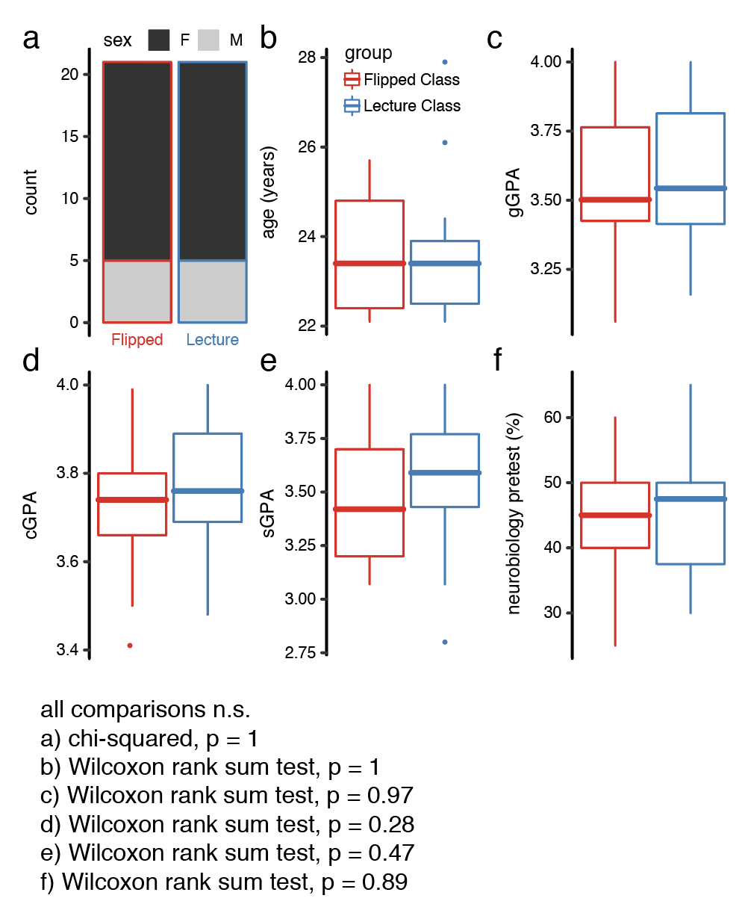

**Supplemental Figure 2: Time spent in flipped and lecture sections.** (a) Students in the flipped section reported spending a greater amount of time preparing for class (“Before Class”) than students in the live lecture section. Although the flipped section had briefer class meetings (“During Class”), the total amount of time spent on each lecture (“Before + During”) was greater in the flipped section. (b) Students in the flipped section spent less time in office hours than students in the lecture section. Students most commonly made use of office hours before each exam (E1–E4; vertical dashed lines). [p < 0.05, ***p < 0.0005, Wilcoxon rank sum tests; ###p < 0.0005, two-sample Kolmogorov-Smirnov test]

